**Project Report**

**Spare Parts Website**

(Online Spare Parts selling website)

**Submitted By**:

* D.S Munasinghe -TAN/IT/2021/F/0026
* P.T Dilshan -TAN/IT/2021/F/0028
* A.K.C Sandaru -TAN/IT/2021/F/0029
* A.M.R.S Alahakon -TAN/IT/2021/F/0030

Contents

Executive Summary: 2

ACKNOWLEDGEMENT 2

LIST OF ABBREVIATION 2

Objectives 3

Efficient Parts Procurement: 3

Comprehensive Catalog: 3

Customer Engagement: 3

Implementation: 3

Challenges and Solutions: 4

Outcome: 4

System design 5

Cart page 7

Category 8

Conclusion: 9

References 9

# Executive Summary:

The Spare Parts Website project was initiated to streamline and enhance the process of procuring spare parts for automotive and industrial needs. This report provides an overview of the project's objectives, implementation strategies, challenges faced, and the achieved outcomes.

# ACKNOWLEDGEMENT

We express our gratitude to the dedicated development team, stakeholders, and users who contributed to the successful implementation of the Spare Parts Website. Your collaboration and feedback have been instrumental in achieving the project's objectives.

# LIST OF ABBREVIATION

**Abbreviation**  **Stands for**

HTML Hyper Text Markup Language

CSS Cascading Style Sheet

JS JavaScript

PHP

# Objectives

## Efficient Parts Procurement:

* Facilitate a user-friendly platform for customers to easily browse, search, and purchase spare parts online.
* Ensure seamless transactions and a straightforward checkout process.

## Comprehensive Catalog:

* Create an extensive catalog with detailed information on each spare part, including specifications, compatibility, and pricing.
* Enhance the user experience by providing accurate and up-to-date product information.

## Customer Engagement:

* Implement features such as customer accounts, order tracking, and personalized recommendations to enhance user engagement.
* Establish effective communication channels for customer inquiries and support.

# Implementation:

1. Website Development:

* Collaborated with a professional web development team to design and implement a user-friendly and responsive spare parts website.
* Utilized modern web technologies to ensure a seamless and secure online shopping experience.

2. Catalog Management:

* Created a comprehensive database of spare parts, categorized and tagged for easy navigation.
* Integrated a robust search functionality to enable users to quickly find the parts they need.

3. E-Commerce Integration:

* Implemented a secure e-commerce platform to facilitate online transactions, including secure payment gateways.
* Incorporated order tracking and status notifications to keep customers informed about their purchases.

4. Customer Support:

* Established a customer support system, including live chat, email, and phone support, to address inquiries and concerns promptly.
* Provided informative guides and FAQs to assist customers in making informed decisions.

# Challenges and Solutions:

1. Data Accuracy:

* Ensured the accuracy of product information by establishing regular updates and maintenance procedures.
* Implemented user feedback mechanisms to identify and rectify any inaccuracies promptly.

2. Security Concerns:

* Addressed security concerns through the implementation of secure sockets layer (SSL) encryption for online transactions.
* Regularly conducted security audits to identify and patch potential vulnerabilities.

# Outcome:

1. Enhanced User Experience:

* The Spare Parts Website has provided customers with a user-friendly platform, resulting in increased user satisfaction and engagement.

2. Increased Sales:

* The online presence and easy accessibility of spare parts have contributed to increased sales and revenue.

3. Customer Retention:

* The implementation of customer support features has improved customer satisfaction and retention.

# System design

➢ Home page

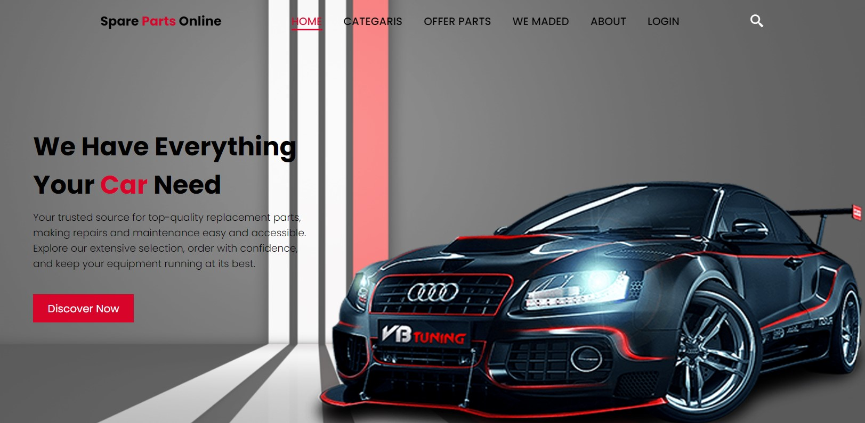

➢ Offer Parts

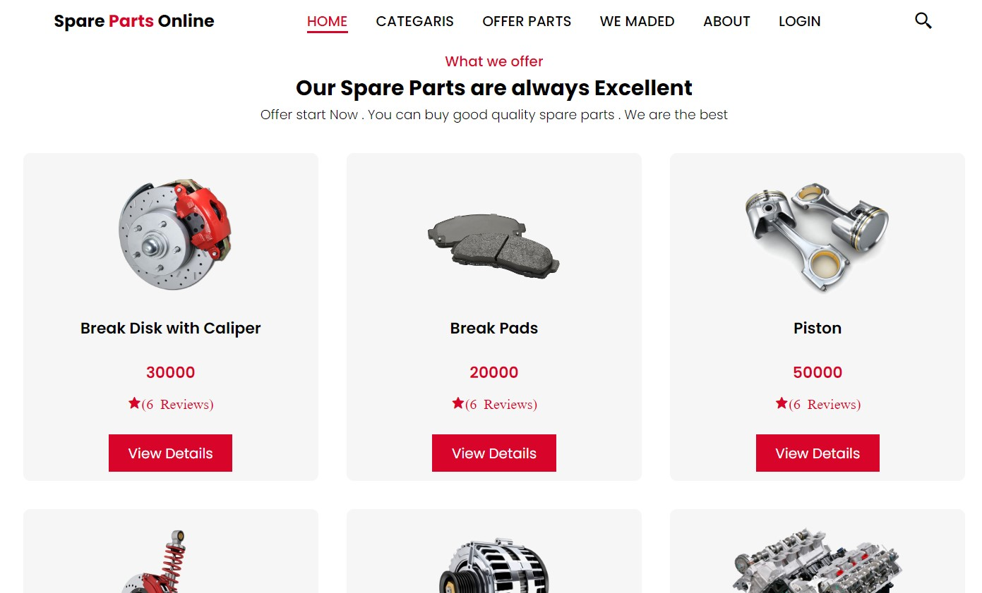

➢ Exhaust Iteam

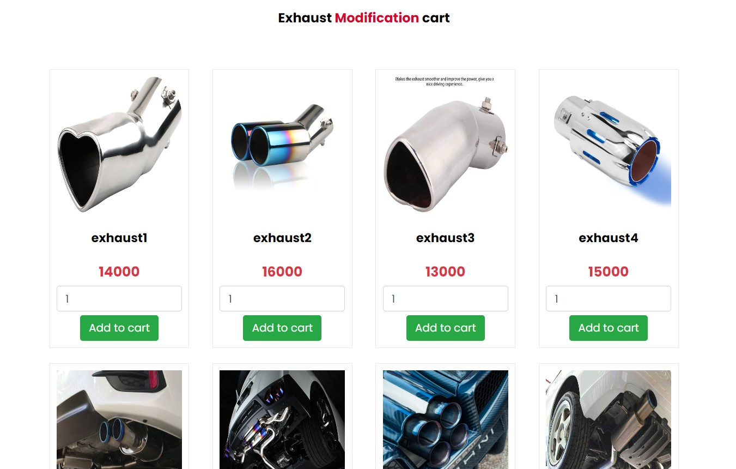

## Cart page

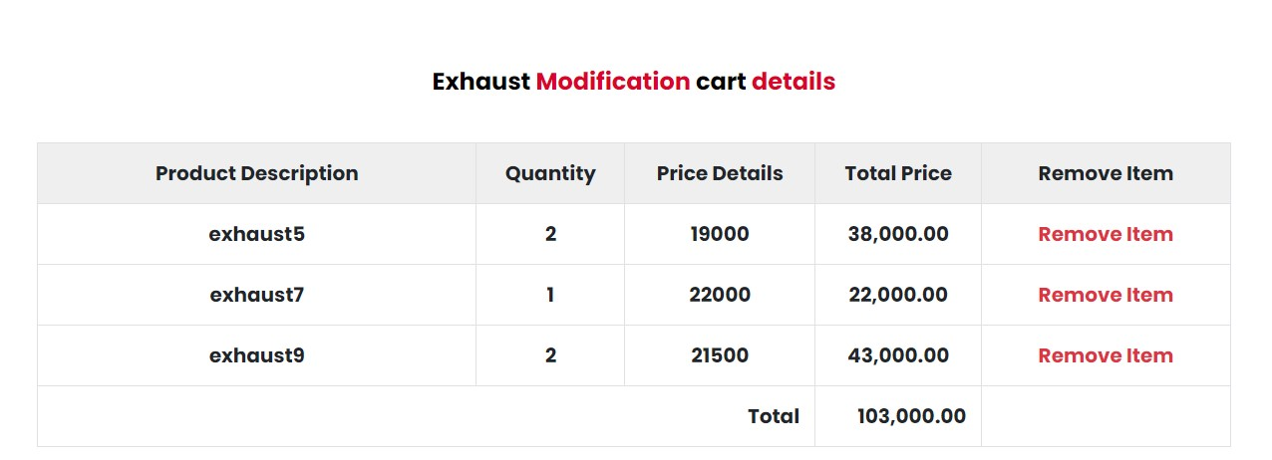

## Category

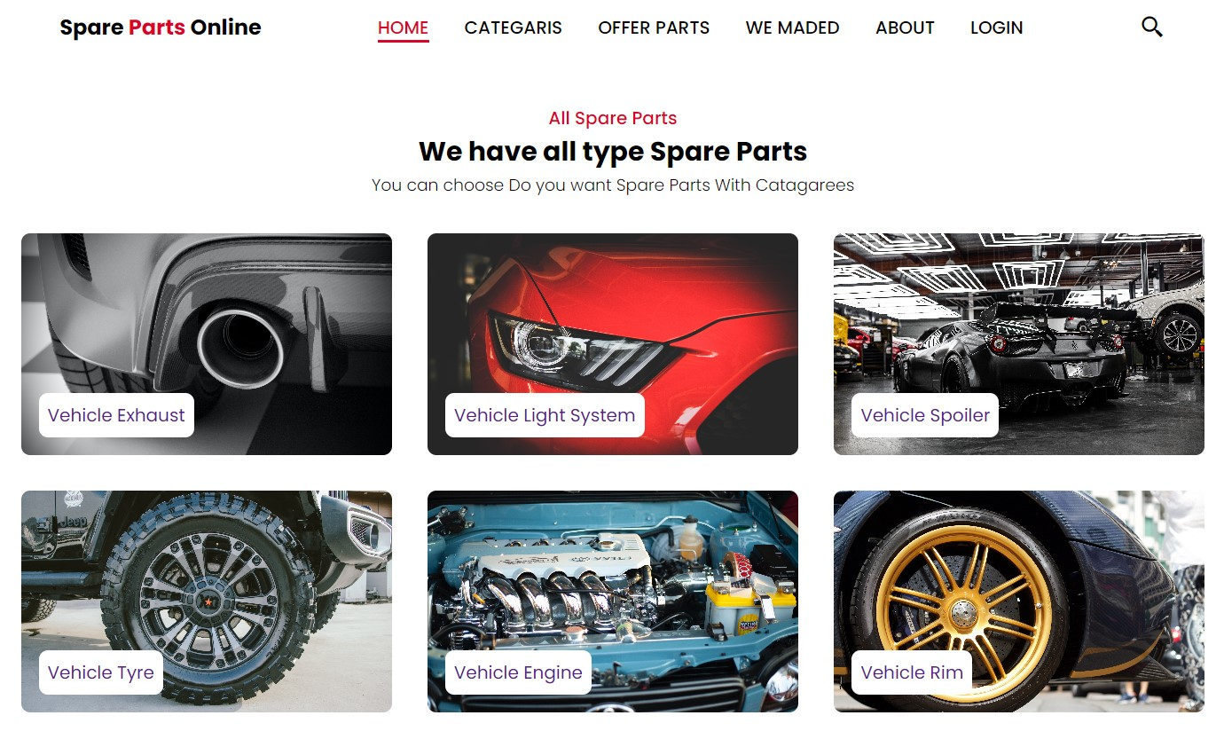

# Conclusion:

The Spare Parts Website project has successfully transformed the spare parts procurement process, making it more efficient, user-friendly, and secure. The positive outcomes demonstrate the value of embracing digital solutions in the automotive and industrial spare parts industry.

# References

* <https://www.tutorialspoint.com/css/index.htm>
* <https://www.tutorialspoint.com/mysql/index.htm>
* <https://www.tutorialspoint.com/html/index.htm>
* <https://youtu.be/KHNA_KwwGKE>
* <https://youtu.be/XpidCpN0h1E>
* <https://youtu.be/FvWpfFo-oww>